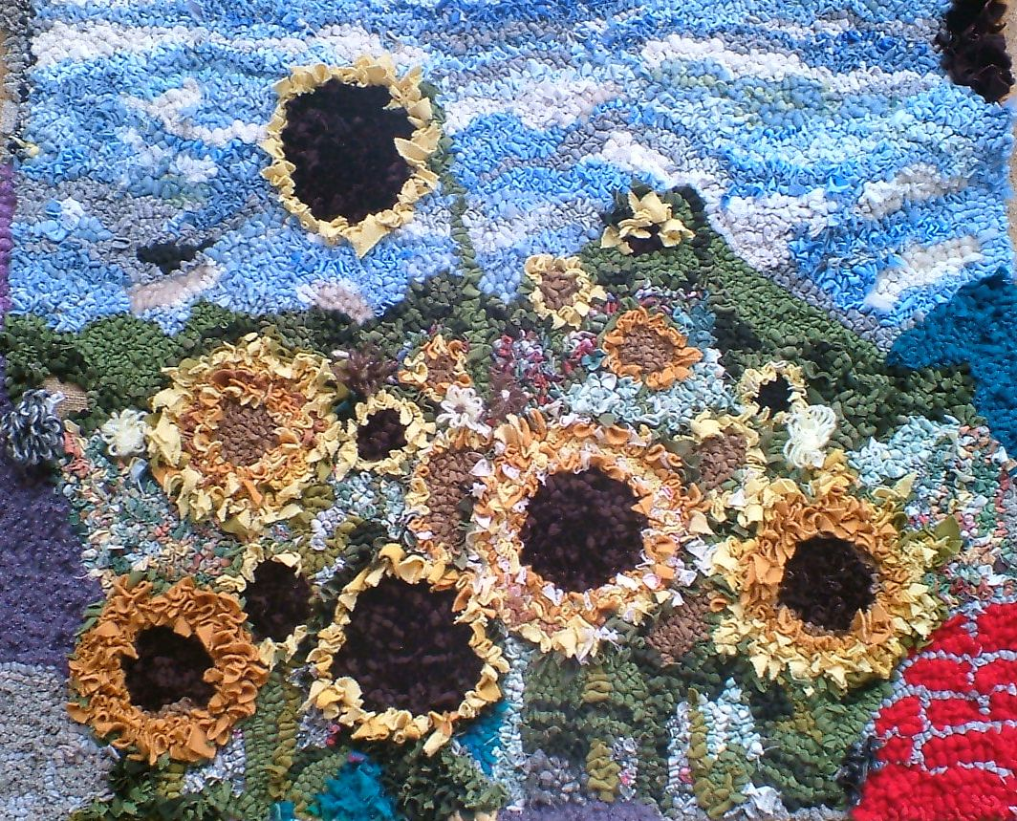
Workshops available:
Materials provided
Monday 21st January 2013 – evening
Saturday 26th January 2013 - morning
Monday 28th January 2013 - evening

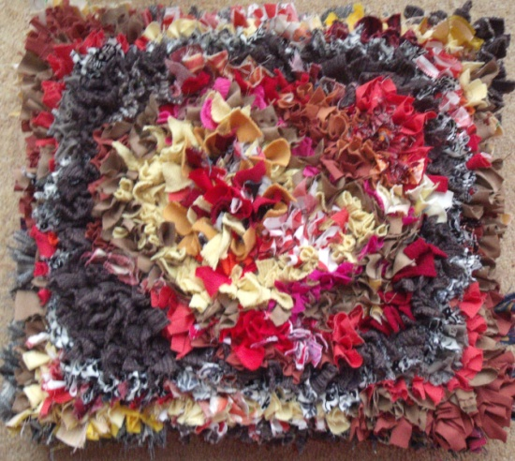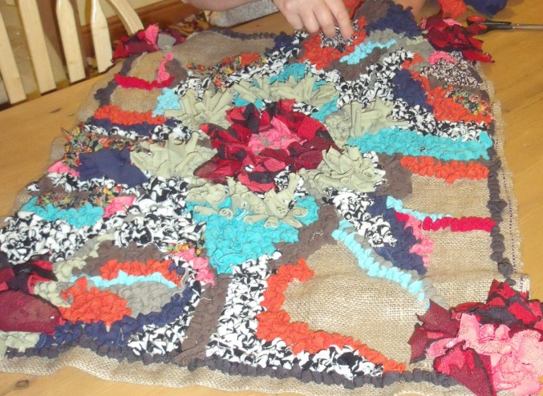

For more information or to book your place please call Eira Walters 07414 531891

